Audie Murphy

Middle School

Fort Hood, Texas



STUDENT HANDBOOK

2022-2023

**MISSION STATEMENT**

Managing our time, resources and expertise, Audie Murphy Middle School faculty and staff will teach so that students learn to their maximum potential every day.

**VISION**

Audie Murphy Middle School, in partnership with the Fort Hood Community,

will cultivate an environment that nurtures the learning of our diverse population

in preparation for their future.

**Audie Murphy Middle School**

**53393 Sun Dance Drive**

**Fort Hood, Texas 76544**

**PH: (254)336-6530**

**FAX: (254)336-6579**

**Principal:**

**Jen Warren**

**Assistant Principals:**

**Yolanda Bailey & Robin Lawrence**

**Coordinator for Special Programs:**

**Suzan Falkner**

**Counselors:**

**Gloria Effinger, Tasha Gardner, & Starlet Bohannon**

**Campus Instructional Specialist:**

**Janet Sutton**

**Campus Instructional Technologist:**

**Deb Blevins**

**Librarian:**

**Jessica Thompson**

# Principal’s Message

**Welcome to Audie Murphy Middle School - Home of the Mighty Falcons!**

Dear Falcon Students,

Welcome to the nest! It’s a huge honor to serve as your principal this year. This will be my 21st year of education, and I have to say that AMMS is truly a great place to be! You’re going to find you have a dedicated group of people here who are going to love you and help you navigate your middle school years successfully. We’re going to teach so that you learn to your maximum potential. This handbook has been created to ensure we cultivate a safe, orderly, and positive learning environment that nurtures our diverse population in order to prepare all of our students for the future. What goals do you have this year? Let’s put in the work and make them happen!

Parents, thank you for allowing me to serve your family. Together we are going to make this a great year.

Peace, Love & Falcon Pride,

Dr. Warren

GENERAL SCHOOL INFORMATION

|  |
| --- |
| Main Office.............................................................................. 336-6530  Attendance Office.................................................................... 336-6533  Clinic........................................................................................ 336-6534 |

Below you will find a listing of some of the personnel who can help you:

|  |  |
| --- | --- |
| AVID Coordinator: | Rodney Cooper |
| Nurse: | Lisa Johnson |
| Kitchen Manager: | Jorinde Roy |
| Principal’s Secretary: | Sheila Rivas |
| Assistant Principals’ Secretary: | Veronica Zapata |
| Attendance Secretary: | Lani Munoz |
| Counselors’ Secretary: | Debra Cruddas |
| Receptionist: | Alisha Edwards-Smith |
| Computer Lab Assistant (ID Cards): | Sharon Sitler |
| Library Assistant: | Jeanne McCleaves |

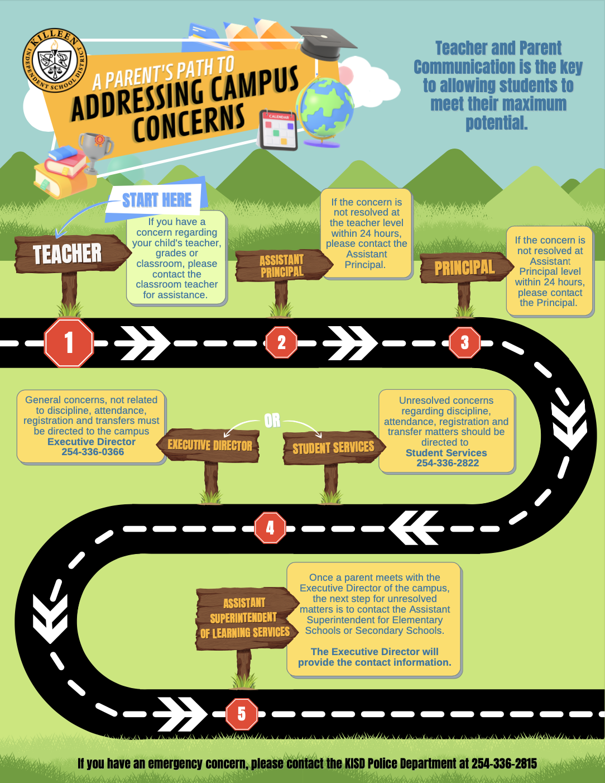

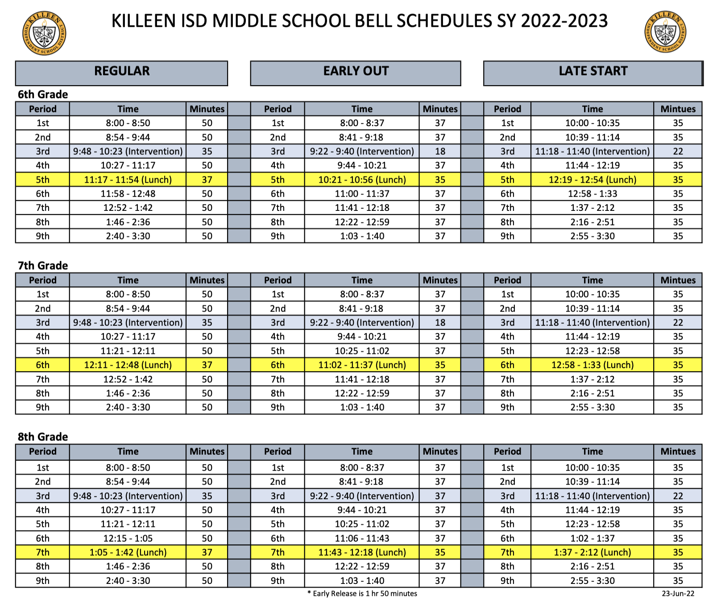

HOURS OF OPERATION

The office at Audie Murphy Middle School is open from 7:30 a.m. to 4:00 p.m. We will provide supervision for students during these hours. All doors, except the main front entrance door, remain locked after the late bell in the morning. The front door is locked promptly at four. Students who remain after school for extra-curricular activities (athletics, fine arts, clubs, tutoring, detention, etc.) must always remain with the activity sponsor in the designated event area. Pick up times and locations should be coordinated between the activity sponsor, parent, and student. Students who are not participating in after school events may not remain on school property after normal business hours. Students who walk home after school are expected to leave campus immediately.

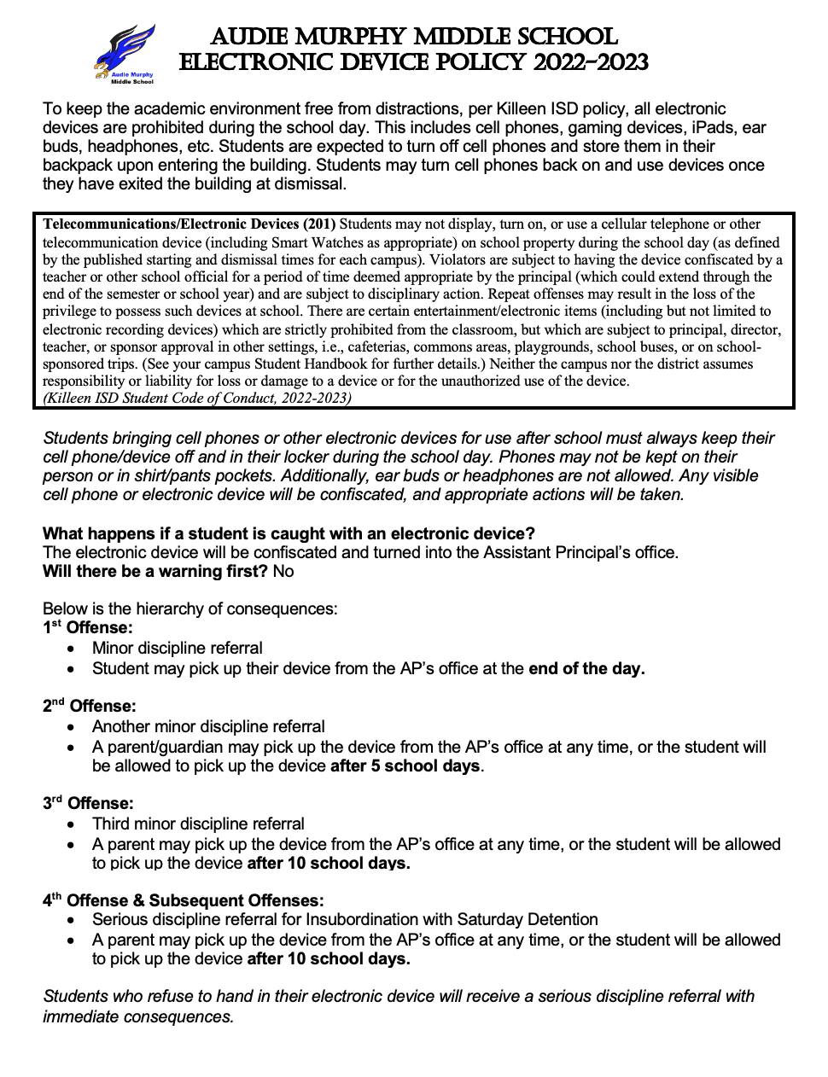

SCHOOL WIDE INFORMATION AND GUIDELINES

AFTER SCHOOL ACTIVITIES

Students attending after school activities must have their ride pick them up no later than 15 minutes after an activity ends. If students are still at school after the 15-minute pick-up time, they may be banned from attending future after-school activities.

All students are required to wear their Audie Murphy ID Card on the appropriate colored lanyard:

Red – 6th grade

Yellow – 7th grade

Blue – 8th grade

Students can wear their own lanyard if the color corresponds with the correct grade level color, or if the AMMS lanyard is worn with the student’s personal lanyard. When attending school events, students are required to wear their Audie Murphy ID and sit in the student section, no roaming/remain seated unless making a purchase at the concession stand and/or using the restroom. Students who are not seated in the student section must be accompanied by a parent. Dress code still applies for after school activities.

Rough housing, horseplay, or other disruptions will not be tolerated at school events. Failure to comply with the student code of conduct and school policies will result in removal from the event.

BACKPACKS

Students will store all backpacks and athletic bags in lockers. No backpacks will be allowed in classrooms or to be carried from classroom to classroom. Students are expected to use lockers this year.

## BEFORE SCHOOL & BREAKFAST

Because the doors are locked and staff members are not available to ensure your child’s safety, we recommend students do not arrive on campus before 7:30 a.m. After entering the building, students who are eating breakfast should go directly to the cafeteria. Breakfast is served until 7:55 a.m., and **it is free for all students** this year. All other students not eating breakfast should proceed directly to their grade level hallway. The

decision to eat breakfast or not needs to be made before students go to their morning hallway.

|  |  |
| --- | --- |
| Doors Open/Breakfast | 7:30 a.m. |
| First Bell | 7:55 a.m. |
| Tardy Bell (Classes begin) | 8:00 a.m. |
|  | |
| Dismissal | 3:30 p.m. |
|  | |
| Early Dismissal | 1:40 p.m. |

BEFORE AND AFTER SCHOOL DROP-OFF/PICK UP AND BUS INFO

Students who are dropped off in the morning before the building opens, should wait on the porch and sidewalk area by the counselor’s entrance of the building. This entrance is located on the front of the school, but it is not the main entrance.

For students riding a bus, please see the information listed below to determine where you will enter the building in the morning and leave the building when the school day is over. If you are unsure which bus you ride, you can find that on the KISD App. We are also here to help!

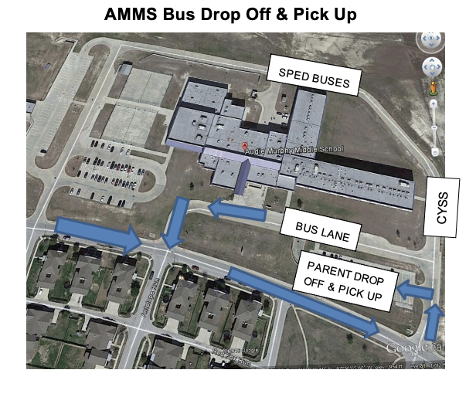

After school, students should exit the building immediately unless attending tutoring or an after-school activity. All students waiting for rides should wait on the sidewalk near the crosswalk. Students will use the crosswalk to meet parents/guardians in the parking lot. Parents, please do not drop off or pick up students in the bus lane at any time.

BICYCLES

Students who ride bicycles to school do so at their own risk. When they get to school and leave at the end of the day, they should **WALK** their bike on/off campus. Encourage your student to **LOCK** their bike to the rack immediately upon arrival to school. The school cannot accept any responsibility for a lost/stolen bicycle. Fort Hood regulations state that bike riders must wear a helmet. Failure to comply with this regulation may lead to a citation being issued by Fort Hood authorities.

BIRTHDAYS

While we know birthdays are a special time, we ask that you please do not send cupcakes or treats for your student to share with others. Students have limited time in classes, and we must optimize the instructional time with limited distractions. We will not interrupt instruction for deliveries.

**CELL PHONES**

Please see page 8 for the Audie Murphy Electronic Device Policy for 2022-2023.

CHANGE OF ADDRESS

If your address or telephone number should change, please report the change to the counselor’s office in person. The district requires an accurate address for state accounting purposes. Additionally, if you move during the school year and will reside outside of the AMMS attendance zone, you must submit the appropriate transfer paperwork for approval.

CLEARING THE BUILDING

All students should clear the building immediately after the last bell unless attending an approved after school activity. Car riders, walkers, and CYSS bus riders are dismissed by the bell. After a couple of minutes, bus students will be called out as buses arrive.

Once bus riders are cleared, students participating in an after-school event or students staying for tutoring will be called to go to their appropriate area.

Students must use crosswalks and sidewalks when exiting the campus and walking in the neighborhoods. This will be enforced by campus administration and Fort Hood Military Police.

CLOSED CAMPUS

We are a closed campus. This means that students are not allowed to leave the campus once they come on the grounds. If students must leave campus for any reason, they must be checked out through the office by an adult listed on their demographic or emergency contact information. Any student who leaves the campus without permission will be subject to disciplinary action.

CLUBS

There are a variety of clubs at Audie Murphy Middle School. Some of the clubs include National Junior Honor Society and Student Council. We are also in partnership with the Comanche Youth Center. Many after school programs will be offered either on campus or off campus with transportation provided by the youth center. Students must be registered with the youth center to participate, and parents must let the youth center know if transportation is needed.

COMMUNICATIONS

* Messages for students will be given only on an EMERGENCY basis.
* Students may call home for emergencies in the AP office, main office, or counselor’s office.
* Staff communication may take place in several ways: a scheduled meeting during the teacher’s conference period, a phone call through the main office for the teacher, or staff members may be contacted through email (It is suggested that your child’s name be in the subject line.) at <https://schools.killeenisd.org/domain/707>
* Medical/Parent forms must be turned into the counselor’s office with sufficient time for the forms to be mailed, faxed or hand carried to the desired recipient.

## COMPUTER USE

There are several computers available for student use at Audie Murphy Middle School. Students will be held accountable on the use and care of the equipment. Any inappropriate or misuse by the student including, but not limited to, visiting inappropriate websites, changing the computer settings without permission, mishandling the equipment, or hacking into other accounts will result in disciplinary action. Every student will need to have a signed Student Code of Conduct Card before using a computer.

COUNSELORS

The school counselors are available to assist students with a wide range of personal, social, and academic concerns. The counselors may also make information available about community resources to assist them with their concerns, when appropriate. If a student wishes to meet with a counselor, they should request a pass from their teacher to go to the counselor’s office to see if they are available or to schedule an appointment.

DANCES

All students are required to wear a school issued ID to school dances.

Rough housing, horseplay or any other disruption will not be tolerated at school events. Failure to comply with the student code of conduct and school policies will result in removal from the event.

DELIVERIES

Deliveries for students are NOT allowed on the AMMS campus. However, parents are allowed to bring lunch up to students during lunchtime. Students will be called to the office at the beginning of lunch to pick up their food in the office.

## DETENTION HALL

Cafeteria detention hall and Saturday detention hall may be assigned by the Principal or Assistant Principal. Teachers may conduct and supervise their own classroom lunch/after school detention hall. Failure to attend an assigned D-Hall may result in a more serious consequence.

## DRUG TESTING

The District requires drug testing of any student in grades 7–12 who chooses to participate in school-sponsored athletic activities and other extracurricular activities that result in the student being a representative of the District.

Students in grades 7-12 who participate in the activities listed below are subject to random drug testing. Students will be tested only if their parents/guardians, and the student, have agreed by signing a consent form. A new consent form will be required at the beginning of each school year. ***If the parent/guardian and/or student do not sign the consent form agreeing to be tested, the student will not be allowed to*** ***participate in any of the listed activities****.* Only random drug testing will be used. At unannounced times throughout the school year, students in the listed activities will be randomly selected to provide a urine sample that will be tested for the presence of drugs. Students are not directly observed when they are giving urine samples. Samples are given in closed restroom stalls. Drug testing is conducted by a certified, licensed organization contracted by KISD. Further information about the KISD random drug testing program may be found in KISD policy FNF (LOCAL).

**Students are randomly selected by the third-party testing company. AMMS does not choose who is tested.**

**\***In addition to athletics, middle school students choosing to participate in the following extracurricular activities are subject to random drug testing: band (marching, concert, and any other band-related groups), choir (all elements), high school theater arts, and academic UIL.

EMERGENCY DRILLS

Emergency drills will be held at unannounced periods throughout the year. Students should follow all teacher directions and procedures regarding the emergency drills.

EXTRA-CURRICULAR ACTIVITIES

Students who pass all classes are eligible to participate in extra-curricular activities. If a student is not in school on the day of any type of extra-curricular activity because of illness, they will not be permitted to participate in any activity that day or night. To protect everyone’s health and well-being, no exception to this policy will be allowed.

Students who participate in these activities are representatives of AMMS and will be held to a higher standard of behavior while serving in that role. Misbehavior of any type may result in disciplinary action taken by the extra-curricular sponsor and/or the school administrator.

FAILURE GRADE GUIDELINES

In accordance with KISD guidelines, {EIA, (Local)}, a student shall be permitted one opportunity to redo an assignment or retake a test for which the student received a failing grade. The guidelines are as follows:

1. Every effort is made to allow students the opportunity to demonstrate their understanding of concepts and skills to achieve mastery.
2. For purposes of the policy, the student contacts the teacher within ten school days from the time the grade is posted in Home Access Center and/or the assignment is returned to the student, whichever is later, to schedule a mutually agreeable time to redo an assignment or retake a test.
3. A grade of 70% or higher indicates mastery of a concept; therefore, students may only redo/retake assignments for which mastery was not achieved.
4. The retake/redo will cover the same material, but it may have different questions or format.
5. A student will only have **one** opportunity to redo/retake any given assignment.
6. The teacher will average the two grades and the maximum grade a student can receive is a 70%. If a student scores lower on the retest/redo, the teacher will take the original score as the final grade.
7. *Assessments and assignments completed during the last week of any grading period are not eligible for redo/retake.*
8. Students may not redo long term projects (projects given a week or more to complete).
9. Late assignments and missing assignments will not be eligible for redo/retake.

HALL PASSES

Hall passes **MUST** be assigned through the e-hall Pass System any time a student leaves the classroom. Students needing to go to the clinic will receive a paper clinic pass as well.

## 

## LATE WORK POLICY

We have a school wide late work policy that will be followed for ALL grade levels. Late assignments may be turned in to the teacher with a penalty assessed on the assignment:

* **First Day Late 10 points off**
* **Second Day Late 20 points off**
* **Third Day Late 30 points off**

After the third day, a zero will be assigned. Students are responsible for turning in their late work. The late work policy does not apply when a student is absent. Every effort will be made to prevent students from failing because of zeros. Students may be required to attend Edge Forward tutoring or teacher directed tutoring to make up work that was not completed.

Work due as part of a long-term assignment will be due when the student returns. KISD policy allows student five (5) days to turn in work following an absence. After this, the late work policy will apply.

LIBRARY

The library is open from 7:30 to 4:00.

Students are responsible for the care of books they check out, as well as for paying fines and/or paying for lost books before being allowed to check out another library book. Two books may be checked out for two weeks at a time. Late fines are $.05 per school day for every day late. Other district mandated fines are:

* + Instructional Materials fines: Water damage ​= **Replacement cost**
  + Broken/bent book cover/binding (non-defective item) = **$5.00 or Replacement cost**
  + Page(s) torn out of book, considered total loss ​= **Replacement cost**
  + Writing on cover/page ​= **$2.00 or replacement**​
  + Missing or tampering with barcode labels = **$5.00**

Textbooks are checked out through the library. If a textbook is lost, the replacement cost must be paid before a new book can be issued. Students must return all textbooks upon withdrawing from the campus.

LOCKS & LOCKERS

Students will be assigned a lock & hallway locker. Students will receive a combination lock to use for the year at no cost to the student. **Students are not allowed to share their locker or their combination with anyone else.** Locks should always be secured. The Assistant Principal Secretary has the locker combinations if a student forgets their combination.

Students may use a personal lock as long as the Assistant Principal Secretary is given the combination or the extra key. The locker remains the property of the school district, and the administration reserves the right to cut off any private lock that is put on a locker without the permission of school personnel. The lock is the property of KISD, and a **lost lock must be replaced at a cost to the student of $7.00.**

Students in athletics or PE who use the gym lockers will need to supply their own lock.

LOST AND FOUND

The lost and found is in the cafeteria. Items of great value are taken to the Front Office. The student is responsible for his/her belongings. **The school is not responsible for personal items.**

Due to the lack of storage and space, all unclaimed items in the lost and found will be donated to local organizations at the end of each grading period. We will make multiple announcements before items are donated.

LUNCH PROCEDURES & PRICES

Students in each grade level have approximately 38 minutes for lunch. Lunches will cost $3.00 this year unless your family qualifies for the reduced/free lunch program. Students may also bring a lunch from home. Students who are bringing lunch from home will need to get their lunch out of their locker before going to the class that will bring them to lunch. For example, if a student has science class right before lunch, the science teacher will bring his/her class to the cafeteria. Hence, students will need to be sure to bring their lunch box with them to science class.

Teachers will bring classes to the cafeteria to drop students off. There will be free seating choice in the café this year; however, a student may lose that privilege at any time if they are moving seats, roaming during lunch, or not following adult guidance.

Although the District will charge for lunch this year, breakfast will be free to all students. No forms are necessary to qualify for free breakfast.

MONEY TRANSACTIONS

Should you have to pay for anything at school (lunch, yearbook, etc.), AMMS will accept cash, checks (no temporary checks), and credit cards.

PERSONAL PROPERTY

Students are encouraged not to bring large amounts of money or otherwise expensive articles to school. All found articles are to be taken to the Lost and Found. Items not claimed will be donated to a charitable organization at the end of each grading period. Any item brought to campus that interferes with or undermines the smooth operation of the general school program will be confiscated and taken to the school’s AP office. The assistant principal will determine the conditions for return of all confiscated items. **AMMS is not liable for lost or stolen personal items.**

SECURITY

**When students come into school late or leave early, they MUST sign in/out in the Main Office.** For the protection of the students, parents, and staff at AMMS, it is required that ALL non-staff entering the building check in the main office and obtain a visitor’s badge through the KISD Visitor Management and Alert System. A photo ID is required to exchange for the AMMS badge. This will be returned when the AMMS badge is returned and the visitor leaves the building. This policy is in compliance with all Fort Hood security measures. AMMS follows Fort Hood R.A.M.P. procedures at all times. Students may also be subject to the AMMS metal detector. Students are NOT allowed to use nor have cell phones turned on while on campus.

SHOT RECORDS

Students will not be able to attend school without a current shot record. Students who become non-compliant during the school year will not be allowed to attend school until the required immunizations have been administered and proof has been given to the school nurse.

STAFF CONTACT

To contact a staff member by email, go to the Killeen ISD website > Schools > Audie Murphy > About Us > Our Staff.

STUDENT PLANNERS

Each student will be issued a student planner at the beginning of the school year. Students are required to use it in all their classes. If a planner is lost, a replacement planner can be purchased for $3.00 through the school library.

TEXTBOOKS

If a student is issued a textbook, return of the textbook is expected at the end of the school year or upon a student’s withdrawal from campus is essential.  Failure to return textbooks, or payment for lost textbooks, can result in a block being placed on the student’s account until the issue is settled.

KISD District policy states: “Each student or his or her parent or guardian shall be responsible for all instructional materials and technological equipment not returned in an acceptable condition by the student. A student who fails to return in an acceptable condition all instructional materials and technological equipment shall forfeit the right to free instructional materials and technological equipment until the instructional materials and technological equipment previously issued but not returned in an acceptable condition are paid for by the student, parent, or guardian.”

TUTORING

Students have the opportunity to attend tutoring both before and after school as specified by teachers. Students are encouraged to do their best academically, but if they find themselves falling behind, it is their responsibility to attend tutoring. If your child is to attend after school tutoring, please coordinate the tutorial time and pick-up with your child’s teacher.

Edge Forward Tutoring is also available in the library to any student who has turned in the completed forms. Students should bring assignments to work on during this time and follow all KISD rules. Edge Forward Tutoring takes place after school from 4:00-5:00PM Monday through Thursday except for holidays or special situations.

REPORT CARDS, PROGRESS REPORTS AND GRADES

Students are required to pass all core subject areas and maintain an overall 70 average. Progress reports and report cards will be distributed according to the District schedule (progress reports every 3 weeks and report cards every 9 weeks). Parents may follow their student’s progress through the KISD Home Access Center.

Performance on the State Mandated Exam (STAAR) may affect the number of electives a student can have the following year.

WITHDRAWAL PROCEDURES

If you are moving, please inform the Counselors’ Office as soon as possible (preferably one week in advance of your last day).

To ensure a smooth withdrawal for students from KISD, parents should begin the withdrawal procedure several days prior to a student’s last day of attendance. This process begins in the Counselors’ Office with a general withdrawal form given to students and parents at the time of withdrawal; this document is usually sufficient for enrollment in another school. Copies of additional documents such as special education or gifted education records will be provided with a 48-hour notice. Students moving during the summer must contact AMMS and complete a withdrawal form to ensure that records are forwarded to the correct new campus.

# ******************************************************************DISCIPLINE

At Audie Murphy Middle School, it is our goal to help the students’ transition from the elementary environment to the less structured secondary environment. Through the guidance and discipline of the staff, we attempt to teach each child both academically and behaviorally. Discipline is administered fairly and equitably while still addressing the individual needs of our students. Recognizing the need for good discipline in a school, teachers and teams establish procedures for successful classroom management using the KISD Classroom Management Framework.

Students and parents should be aware of the District’s Student Code of Conduct, which can be found on the Killeen ISD website. Along with the schoolwide expectations, each teacher has his/her own set of class expectations.

While the staff attempts to correct student misbehavior with verbal warnings, there may be times when it is necessary to write a referral on a student. Referrals may be serious or minor depending on the situation. We ask that all students follow the KISD Student Code of Conduct and AMMS guidelines and rules.

**\*\*See Student Code of Conduct for additional information.**

CAMPUS CONSEQUENCES FOR MISBEHAVIOR

Students may be assigned by teachers to a detention hall (d-hall) for inappropriate behavior. This detention may be held before school and/or after school (Monday-Thursday). Students will receive a d-hall assignment slip indicating when and where the detention is to be served. **It will be the student’s responsibility to notify/take that slip to their parents.** Students who fail to complete the assigned days will be subject to further disciplinary action. Students may also be assigned to a detention hall by an administrator. This is reserved for behavior which is considered more serious.

If a student is consistently disruptive or engages in severe misbehavior, the student may be assigned In-School Suspension (ISS) or Out of School Suspension (OSS). Misbehavior in ISS may result in Out of School Suspension (OSS).

If a student’s behavior hinders the educational process and/or the student is deemed to be a danger to others by the administration, the student may be suspended from school.

If a student returns to Audie Murphy or any other KISD campus during the suspension period, the student will be referred for possible criminal action.

When a student engages in persistent misconduct (classroom disruption, horseplay, etc.) he/she may be placed on campus probation. When a student is placed on campus probation, the student is close to exhausting all campus-based discipline measures. This probation serves as a final warning for the student. If the student continues to engage in misconduct after the campus probation is implemented, a district level due-process hearing may be scheduled. The District Hearing Officer will determine the appropriate district consequence.

**CYBERBULLYING**

Students can be held accountable at school for cyberbullying that is done off campus if the students attend AMMS. Cyberbullying is any bullying that is done using any electronic

communication device, including using cellular phones, a computer, a camera, email, DMs, text messaging, or any other social media application. (TEC §37.0832) In the event the school is made aware of a cyberbullying incident, administrators will investigate. If the facts from the investigation indicate you are involved in cyberbullying, the excuse of “this is how we talk to each other” is not going to suffice when it comes to assigning consequences. Be a kind human.

DRESS CODE

Students shall be dressed and groomed in a manner that is clean and neat and that will not present a health or safety hazard to themselves or others. All dress code issues will be subject to the campus administrator’s judgement.

Students who are considered in violation of the dress code shall be advised by the campus administrator and shall be given an opportunity to comply. The opportunity to comply may take a variety of forms. *Students will be given the opportunity to call parents/guardians for a change of clothes. While awaiting the change of clothes, students will be required to wait in the ISS room.*

Students who fail to comply or who repeatedly violate dress code shall be subject to disciplinary action. Dress code applies to all students who attend after school events or activities.

More details about acceptable dress and grooming may be found in the District’s Student Code of Conduct on pages 39 and 40. We follow the District Dress Code Policy. Below are a few examples of AMMS’s dress code expectations:

1. No lewd, offensive, or obscene shirts. Also, no advertisements for tobacco, alcohol, or drugs.
2. No spandex pants, bike shorts or leggings that are not covered by a top or a skirt.
3. District policy is NO pants with holes any higher than 6” above the knee. Jeans with holes are okay at AMMS, but if you have holes more than 6” above the knee you must wear leggings underneath. (No skin showing.)
4. Shorts and skirts may not be shorter than 6” above the knee.
5. Sweatshirts with hoodies are allowed, but hoodies must be down inside the building.
6. No hats inside the building.
7. No pajama pants or pants that look like pajamas.
8. Tank tops and crop tops are not allowed. This includes under zippered hoodies.
9. No house shoes, water shoes, shoe skates, or shoes with metal spikes.
10. No visible “thigh high” panty hose.
11. No anime, cosplay, or other costumes.
12. No toys, stuffed animals, or blankets.
13. Students will always wear their student ID on the appropriately colored lanyard around their neck. No hanging IDs out of pockets.

Remember that you make a conscience decision each morning when you decide what you are going to wear. Please don’t make a choice that is going to start your morning off in ISS.

FOOD AND DRINKS

Students are allowed to bring water to school in any clear container. Coffees, soda, and other colored drinks are not allowed. Eating in classrooms and hallways is not allowed unless there is a special occasion or if there is a medical necessity.

ISS (IN SCHOOL SUSPENSION)

ISS is used in lieu of removing a student from the campus setting. During their time in ISS students will be provided assignments and are expected to complete all work given to them.

**ISS Rules and Guidelines are:**

1. Students report to the designated ISS waiting area after eating breakfast.
2. Students must bring all assigned textbooks, workbooks, and any other assigned materials. This includes pencils, pens, markers, paper, and any other necessary supplies.
3. There will be NO talking or whispering. Students must raise their hand AND wait to be recognized before talking to the instructor.
4. Chewing gum, candy, food, or drinks are not allowed to be consumed in the ISS Room. Students may bring their lunch from home but cannot consume it in the ISS Center until the designated lunch period.
5. All students must sit at their assigned desk with their head and eyes facing the front of their desk. Students must remain seated at all times unless given permission by a staff member.
6. Sleeping is not allowed or resting of the head on the desk, back of your arms or the chair.
7. During the lunch break students will be accompanied to the lunchroom to get their lunch; however, lunch will be eaten in the ISS room.
8. Students must complete ALL assignments and turn them into the ISS Instructor. Students must work continuously on completing assignments or a warning consequence will be given.
9. Students will be escorted out of school at the dismissal bell.
10. ALL KISD and campus rules will be enforced. Students must be within dress code expectations.
11. The attendance of a student in ISS during and/or after school activities such as sports events, UIL activities, or dances is not allowed.

**Any violations of these rules while in ISS will result in further disciplinary action. The following consequences may be administered depending on the severity of the offense:**

1. First Offense: A verbal warning and phone call home from the ISS Center. Documentation of all contacts will be kept on file.
2. Second Offense: Suspension from school.

PROHIBITED ITEMS

There are certain items that students are prohibited from using, displaying, or possessing at school. Those items include, but are not limited to:

*Skateboards/Roller blades/Wheelie Shoes (Students who ride skateboards to school may bring their skateboard to the front office where we will hold it for you until dismissal.)

*Laser light devices, electronic entertainment devices, or games

*Cameras/Video cameras

*Hats inside the building

*Water guns/Toy guns

*Toys, stuffed animals, blankets

*Body sprays, cologne, perfume, aerosols

*Costumes, cosplay outfits, masks

**THREAT**

Threats made in any form toward others will not be tolerated. This includes any physical, written, or verbal threats, whether actual or implied. Also included is any form of intimidation that endangers and/or threatens to endanger the mental, emotional, or physical health of another person. Do not joke around and threaten someone to be funny. It is not funny to the person you are talking to or to others who overhear your threat. Joking about violence or hurting someone is never funny, and you will encounter serious consequences regardless of whether you really meant it or not.

**WEAPONS, IMITATION WEAPONS, BULLETS**

A student shall not knowingly, intentionally, or recklessly possess or bring on to the school premises, nor attend any school activity, function, or event with any item that may be considered dangerous to that student or to other students. This includes, but is not limited to, any item that is designed to look like, or is purported or represented to be, a weapon or ammunition of any kind. Do not bring water guns or bullets (even if they are not live). Possession of any of the above items will be considered a serious offense. Joking about having any of these items will also be considered a serious offense.

Make it a great day Falcons! The choice is yours!



*\*\*The guidelines outlined in this handbook are subject to change based on KISD Policy and/or campus needs. Furthermore, this serves as an addendum to the KISD policies and procedures.*